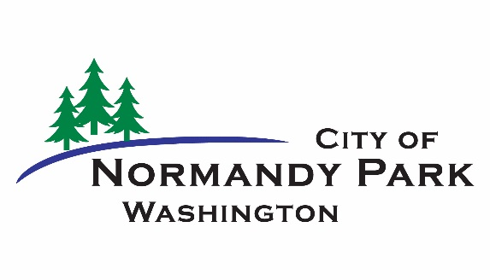
Normandy Park City Council Meeting
Meeting Date: August 10, 2021

Agenda Category: New Business

Agenda Bill #: 793

SUBJECT: Directing a Type V code amendment work item to the Planning Commission to comply with state legislation in E2SHB 1220 regarding code provisions for newly legislated supportive housing types.

ATTACHMENTS:

- E2SHB 1220

PRESENTED BY: Nicholas Matz AICP, Community Development Director

REVIEWED BY: City Manager and City Attorney

STAFF EXPLANATION:
On July 6, City Councilmembers received background information on recent state legislation regarding affordability in housing, following a request by Councilmember Thompson on the importance of understanding how this legislation (ESSB 5235 and E2SHB 1220, adopted July 25) could influence housing supply in Normandy Park.

The Municipal Research and Services Center, in a June 29 blog post, noted, “Homelessness and affordable housing are two major and difficult issues facing communities throughout the state of Washington. To help address these complicated issues, E2SHB 1220 was recently signed into law and is meant to encourage code cities to take active steps to accommodate transitional housing, emergency shelters, and similar homelessness-related facilities through local planning and changes to local development regulations.”

This background information “bookend” leads the city to the second “bookend,” which is that in response to mandates in E2SHB 1220 the city will need to take action in fairly short order to accommodate four newly-identified supportive housing types regarding housing affordability and availability for homeless persons, families and households:

- Transitional housing means a project that provides housing and supportive services to homeless persons or families for up to two years and that has as its purpose facilitating the movement of homeless persons and families into independent living.
- Permanent supportive housing...means subsidized, leased housing with no limit on length of stay, paired with on-site or off-site voluntary services designed to support a person living with a disability to be a successful tenant in a housing arrangement, improve the resident's health status, and connect residents of the housing with community-based health care, treatment, and employment services.
- Emergency housing means temporary indoor accommodations for individuals or families who are homeless or at imminent risk of becoming homeless that is intended to address the basic health, food, clothing, and personal hygiene needs of individuals or families. Emergency housing may or may not require occupants to enter into a lease or an occupancy agreement.
- Emergency shelter means a facility that provides a temporary shelter for individuals or families who are currently homeless. Emergency shelter may not require occupants to enter into a lease or an occupancy agreement. Emergency shelter facilities may include day and warming centers that do not provide overnight accommodations.
The legislation requires that transitional and permanent supportive types of housing not be prohibited in any zones in which residential dwelling units or hotels are allowed, and that emergency housing and emergency shelter uses not be prohibited in any zones in which hotels are allowed. Fortunately, the legislation allows for “reasonable occupancy, spacing, and intensity of use requirements [which] may be imposed by ordinance...to protect public health and safety.”

This legislation encourages a thoughtful, broad approach to how and who we house with these types of supportive housing. Normandy Park is a community of predominantly single-family homes, while attached housing makes up 30 percent of our housing stock. Communities all over the region are becoming aware of the different ways that households and families form economic units—and now, unfortunately, how those units can dissolve into homelessness. This has meaning for the preservation and addition of housing stock, to keep a community aware of its own vision and future:

Assessing the NPMC in this regard notes that the code does not specifically identify how these types of uses would be permitted, with the exception of regulations in Title 18.110 for temporary homeless encampments.

The approach that staff recommends to these code amendments will be to examine the minimum necessary to reach compliance regarding not prohibiting these newly-defined supportive housing uses, including aligning them with existing uses, definitions, and permissions in Title 18.

For example, transitional housing and permanently supportive housing may be able to fit into the dwelling unit’s definitions as a recognized type of household while emergency housing and emergency shelters may be able to piggyback on the existing temporary homeless encampments regulations and that code section’s occupancy, spacing and intensity of use requirements.

The new legislation also identifies city’s abilities to regulate occupancy, spacing and intensity of use limits, tailored to the projected homeless populations capacities that Commerce will define for each city based on countywide need.

Because the legislation prohibits the city from enacting short term moratorium provisions in RCW 36.70A.390 to prevent supportive housing uses where residential dwelling units or hotels are allowed, staff recommends directing the Planning Commission to define and permit the four types, with appropriate occupancy, spacing, and intensity of use requirements, and to return a proposed ordinance for City Council consideration.

FISCAL CONSIDERATION: There is no direct cost to carrying out a Type V municipal code amendment. The city could see increased costs associated with litigation defending the municipal code without provisions for supportive housing uses.

POLICY CONSIDERATIONS: The Comprehensive Plan’s Land Use and Housing Elements provide guidance on housing placement and affordability. The city has a track record of making informed decisions about affordability in housing, including:

- Adoption of transfer of development rights (TDR) in the Manhattan Village Subarea (2013);
- Partnering with other south Sound communities in the South King Housing and Homeless Partners (SKHHP); and
- Imposing a local sales and use tax for affordable housing (2019) as a result of other recent legislation (SB 1406)—and then in turn entering into an interlocal agreement (2021) with SKHHP to pool this share of the state’s sales tax for local provision of affordable housing.

The temporary homeless encampment regulations were adopted in 2016.

COUNCIL OPTIONS:

- Move to direct a Type V code amendment work program item to the Planning Commission to comply with adopted state legislation in E2SHB 1220 regarding code provisions for newly-legislated supportive housing types.
- Take no action.

RECOMMENDED MOTION:

“I move to direct a Type V code amendment work program item to the Planning Commission to comply with adopted state legislation in E2SHB 1220 regarding code provisions for newly-legislated supportive housing types.”

